Fully Automatic High-Speed Self-Adhesive Label Packaging Production Line
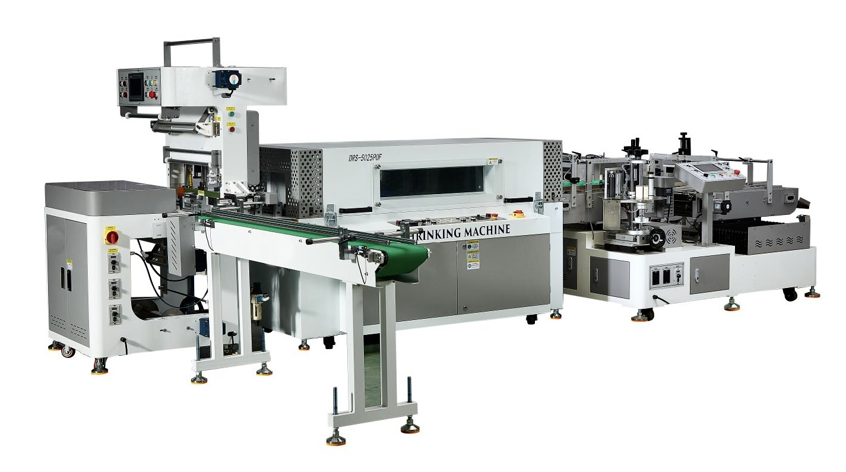
Equipment Layout：
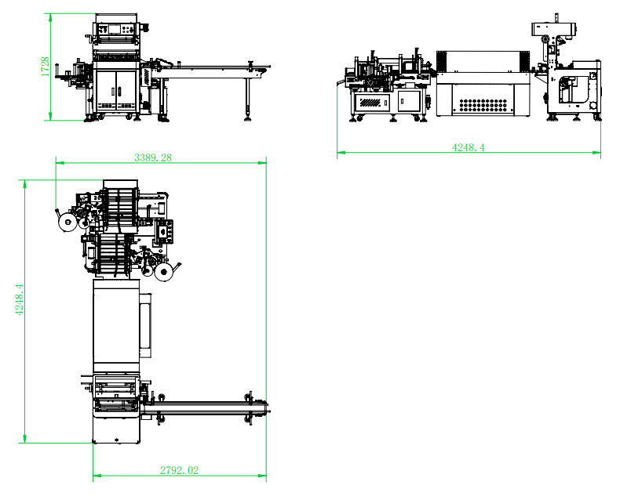

Basic Use：
It is mainly applicable to the whole or single package of OPP sealing tape, stationery tape, masking tape, etc.

Equipment Advantages：

lmpulse type cold-sealing cutter ensuring smooth edge free from per-heating,which is more convenient to use and emerging saving。Cutting edge of 500mm in effective width。

The width and diameter can be adjusted by DC motor, with precise positioning, convenient and fast, and suitable for packaging products of different widths.
- One machine can be used for multiple purposes. Products with a width of 40-350mm can be packaged either individually or in multiple packages. The specification can be adjusted by one button without manual operation.
- The packing speed can reach 28 drums/minute.
- Steel structure for the entire machine,stable and solid。
- Automatic material feeding into the production line。Production line and body mounted separately,more convenient for transportation
- Discharging in a fixed position without worry about loose packaging
- Storage structure for more stable film feeding without deviation
- Separation structure ensuring more smooth material pushing despite of the adhesion of sealing tapes
- It can be connected to the rear of the full automatic slitting machine and manual slitting machine to realize the unmanned operation in the middle。
- The insulation layer of the intelligent visual variable frequency heat shrink machine heating system is made of high-temperature resistant rock wool, which has a low surface temperature during operation and reduces heat loss. The heating tube is made of stainless steel heating tube, with a long service life.
- The air transportation system is specially designed with an air duct circulation system, which ensures even heating of the product. With dual high-power imported air transportation motors, the air volume inside the contraction furnace is large and uniform, and the wind force can be adjusted.
- The outer plate of the heat shrinking machine is made of ordinary carbon steel plate, which is bent and sprayed with plastic on the surface. The inner plate is made of galvanized steel plate by hydraulic pressure.

Main technical parameters：
Name/Model | STB-500G | DRS-5025POF
Applicable Range (D×H) | Ø（40-160）* H(40-350)MM
Heat Shrink Tunnel Dimension |  | 1500*450*250mm
Packing speed | 28 pcs/min | 20-40 /min
Power supply | Single-phase AC200-240V, 450W | 13KW
Air supply pressure | 6KG
Net weight | 300KG | 230KG
SIZE | 3150(L)*2800(W)*1780(H) | 1800*900*1120mm
Packing film | POF

Configuration parameters：
Model | STB-500G | DRS-5025POF
frequency converter |  | cost
touch screen | Mcgstpc
speed motor |  | Zhan Peng
Three phase asynchronous fan |  | Yunchi
Phase failure and phase sequence protector |  | chint
PLC | San J IE lI CHSJL
DC Motor | ing
air switch | chint | chint
Switching Mode Power Supply | Mingwei
Contactor | Schneider | chint
relay | IDEC | chint
Button switch | Kndele | heli
thermostat |  | Beimei
Solenoid valve | China STNC
filter | China STNC
Cylinder | STAR | STAR
electric machinery | sanly | Zhan Peng
governor | sanly
Photoelectric sensor | Taiwan Yangming
proximity switch | CNTD
Bearing | NSK HRB | HRB
Pneumatic joint | EASUN | China STNC
High temperature adhesive tape | JAPAN NITTO
Heating Tunb |  | 1.8KW  Metal ring
Insulation layer |  | Made of high-temperature resistant rock wool

SST-400A Double side labeling machine

Basic Use：

It is mainly suitable for single-side and double-side labeling of cylindrical materials, such as self-adhesive labels, bar codes and other double-side labeling, both sides of the same labeling, double labeling to improve production efficiency, widely used in daily chemical, cosmetics and other industries.

Equipment Advantages ：

◆ Intelligent control, automatic photoelectric tracking, with the functions of no matter what, no label, no label automatic correction and label automatic detection, to avoid wasting labels and missing labels.

◆servo control labeling, servo control drum line, double side separate labeling, more stable performance, more accurate labeling, the speed of up to 80 rolls a minute.

◆ Adjustable width and diameter, adjustable by sliding rail, accurate positioning, convenient and fast, suitable for packaging products of different widths.

◆Waste collection using magnetic powder clutch control, not easy to break the bottom paper.

◆ servo control labeling, servo control drum line, double side separate labeling, more stable performance, more accurate labeling, the speed of up to 80 rolls a minute.

◆ The main materials of the equipment are A3 steel and high-grade aluminum alloy. The overall structure is firm and beautiful.

◆The double side plastic synchronous green guide chain is used to reduce the damage to the product and the difficulty of manual operation.

◆ configuration of continuous bidding structure, ensure that the product labeling is smooth, not easy to fall off. The automatic separation structure is configured, and the product is automatically separated from each other to ensure the stability of conveying and labeling

◆One machine can realize single side and double side labeling of multiple products.

Main technical parameters：
Model | SST-400A
Applicable product diameter*height | Ø（45-150）* W(40-400)MM
Applicable label range | Length 10-260mm ，Base paper Width  10-150mm(Customized Label Cover Tape）  Applicable Label Length 10-260mm  Applicable Label Liner Width 10-150mm (customized label pressing belt available for special widths)
Maximum Label Supply | Max. Label Roll OD ≤300mm  Label Roll Core ID 76mm
Labeling speed/min | 1-80 PCS/MIN（subject to product and label dimensions）
Labeling accuracy | ±1mm（excluding tolerance from product and label itself）
Power supply | AC200-240V,50-60HZ 4KW
Machine size | 1860(L)*1840(W)*1130(H)
Net weight | 300kg

Configuration parameters：
Model | SST-400A
touch screen
Labeling servo | HCFA
Labeled driver | HCFA
Drum line servo | HCFA
Drum line driver | HCFA
Waste collection brushless DC motor | MAIL I
Translational constant speed motor | MAIL I
Paddle speed motor | MAIL I
governor | MAIL I
Front conveyor rail assembly | custom
Rear transfer rail assembly | custom
Front labeling slide assembly | custom
Product sensor | BOJKE
label sensor | BOJKE
Magnetic powder clutch | YOSEEN
Magnetic powder brake | YOSEEN
Planetary reducer | SIMAIT
power switch button | KENAIDA
Switching Mode Power Supply | Mingwei
bearing | NSK HRB

